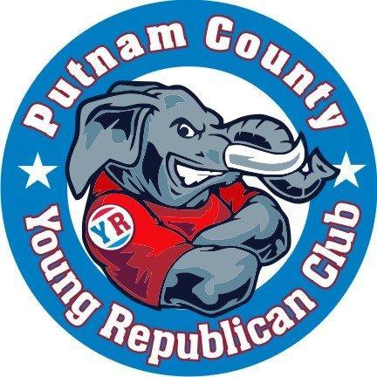

MEMBERSHIP APPLICATION

Date: ____________________

Name: ______________________________________________________________
Address: ____________________________________________________________
Primary Phone Number: ____________________
Email Address: _______________________________________________________

There are five (5) classes of membership in the Club
.
A. Active Membership: Any registered Republican or Conservative who is not more than forty (40) years of age and is a resident of Putnam County is eligible for active membership in the Club.
B. Associate Membership Any registered Republican or Conservative who is not more than forty (40) years of age and is a non-resident of Putnam County is eligible for associate membership in the Club (special exception for Teenage Republicans).
C. Supporting Membership Any registered Republican or Conservative who is outside the age or residency parameters of the active or associate memberships.
D. Honorary Membership (Young at Heart): Honorary members shall be those people, designated for honorary membership by two-thirds of the Executive Board and three-fourths of those members present at any regular meeting of the Club. There are no residence or age limitations for this category of membership.
E. Teenage Republicans (TARS): TARS are part of national, youth-based organization challenging, training, and assisting teens to become involved in their local, state, a notional political process. This special associate membership is permitted for qualified youths who want to be a part of the YR’s greater mission.

NOTE: All membership opportunities, other than Active Membership, are strictly offered as an affiliate status granting no official “voting rights” for matters pertaining to club business.

What type of membership are you applying for? _____________________________________________

Identify which club committees you are interested in: __________________________________________
_____________________________________________________________________________________

Membership, Marketing/PR, Finance/ Fundraising, Political Activities, Publicity/Community Activities, Youth Committee (TARS Liaisons), By-Laws, Special Events (Teddy Dinner)

Background

Employer / Occupation: _________________________________________________________________

Please list other organizations of which you are a member: _____________________________________________________________________________________

How did you hear about the Putnam YR Club? _____________________________________________________________________________________

Why do you want to join the Putnam YR Club? __________________________________________________________________________________________________________________________________________________________________________

Have you ever volunteered with a political organization? □ Yes □ No

Additional Comments:
__________________________________________________________________________________________________________________________________________________________________________________________________________________________________________________________________________________________________________________________________________________________________________________________________________________________________________________________________________________________________________________________________________________________________________________________

Please return application to the Putnam YR Secretary at Secretary@PutnamYR.com , or deliver in person at one of the club’s monthly meetings/ events.

For meeting/event details, view the club’s calendar online at www.PutnamYR.com/Calendar

